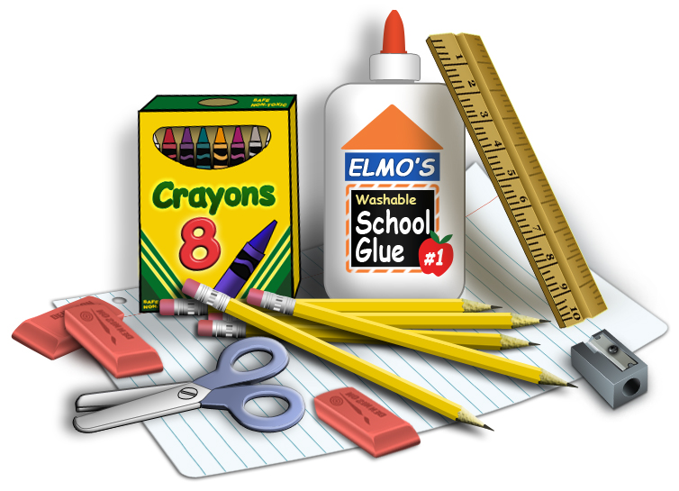

Wallace School of Integrated Arts
General School Supply List

1 Box of Baby Wipes
1 Mask
1 Personal Reusable Water Bottle
1 School Box
2 Glue Sticks
1 Pair of Earbuds or Headphones
2 Boxes of tissues
10 #2 Pencils

Thank you for your support. We look forward to a great school year!

